Finance Formulas

**Financial Cash Flow**

**Cash flow from Assets = Cash flow to creditors + Cash flow to stockholders**

1. Cash flow from assets = EBIT + DEP - Taxes - Net Capital Exp. - Change (NWC)

2. Cash flow to creditors = Interest paid - New Borrowing

3. Cash flow to shareholders = Dividends paid - New equity

Net Capital Exp.= Ending Net Fixed Assets- Beginning Net Fixed Assets + Depreciation

Change (NWC)= Ending NWC – Beginning NWC

NWC =CA -CL

##### Retention Ratio =RR =1-DPR

##### Internal Growth

##### 

##### Sustainable Growth Rate



**Time Value of Money Terminology:**

FV= Future Value, C0 = present value=PV, C = cash flow (annuity), T= periods

R= interest rate,

##### I. Future Value

a. Single sum: 

b. Ordinary Annuity:



c. Annuity Due:



**II. Present Value**:

1. Single sum:  

b. Ordinary Annuity:



Present Value of Growing Annuity



Growing Perpetuity



c. Annuity Due:



d. Uneven Series of Cash Flow: 

e. Perpetuity: 

III. **Compounding Interest with Non-annual Periods:**

1. Effective Annual Rate (EAR):

APR =

1. Future value:



C. Continuous Compounding:





**IV. Net Present Value: **

**STOCKS VALUATION**

**Terminology:**

Dt  = dividend the shareholder expects to receive at the end of year t.

D0 = the most recent dividend which has already been paid (ex-dividend).

P0 = actual market price of the stock today

Pt = expected price at the end of the year t.

Dt /P0 = expected dividend yield during the coming year t.

(Pt - P0)/P0 = expected capital gains (loss) yield during the coming year t.

g = expected growth rate = RR x ROE

R= rate of return on common stock

Dp = dividend on preferred stock

Pp = preferred stock price

Rp = rate of return on preferred stock

**STOCK VALUATION:**

**A. Preferred Stock:** 

**B. Common Stock Valuation**: **Valuation of Different Types of Stocks:**

Case 1: **Zero Growth**: 

Case 2: **Constant Growth Rate: dividends grow at a rate of g forever.**



Case 3: **Super (Differential) Growth**:



The value of PT is calculated as a growing perpetuity.



P0 = PA +PB

**C**. The expected rate of return on the stock is the sum of dividend income yield and capital gain (loss) yield.



**D. Price-Earnings Ratio**:

One frequently used method among financial analysts is based on the P/E ratio. That is,

Price = EPS x P/E

# Bond Valuation

Terminology:

Par=F= face or terminal value C= Coupon payment, C = Par x CR

CR= Coupon Rate T=Maturity Date

R =Rd =Discount rate, required rate of return, Interest rate. PB = Price of a bond

**Forms of Bonds**:

1. Pure Discount Bond: 
2. Level - Coupon Bonds





3. Consols (Perpetuities):

**Estimation of Yield-to-Maturity:** 

### CAPITAL BUDGETING

**DEFINITION OF THE TERMS**

C0 = Initial Outflow

CF = Cash Flow SV = Salvage Value

ANPV = Adjusted Net Present Value DEP = Depreciation

MIRR = Modified Internal Rate of Return OC = Operating Cost

NIAT = Net Income After Tax NWC = Net Working Capital

PI = Profitability Index R = Cost of Capital

1. **Net Present Value**



1. **ANNUITY CASH FLOWS**:



**B. UNEVEN SERIES CASH FLOWS**:



**2. CALCULATION OF IRR**: IRR is a discount rate at which the NPV = 0.





**C. MODIFIED IRR:** 

This method overcomes the reinvestment rate deficiency inherent in the regular IRR.

3. **Payback period (PBP)** is defined as the expected number of years required to recover the original investment.

4. **Average Accounting Return** (ARR) compares the average net income after-tax with the average dollar size of the investment including the salvage value (SV).

**5. PROFITABILITY INDEX**: It is the ratio of the present value of cash flows divided by the initial outflow. 

6. **Investment of Unequal Lives projects: There are two methods for the adjustment of unequal lives’ projects:**

**1. The equivalent annual cost (EAC):** 

**Assumes investment s are in the same risk class.**

1. Adjusted Net Present Value (ANPV): 

Adjust for the risk differences among the investments.

**DECISION CRITERIA**

**1.NPV>0, IRR>R, PI>1, Accept**

**2.NPV<0, IRR<R, PI<1, Reject**

**3.NPV=0, IRR=R, PI=1, Accept**

**CALCULATIONS OF CASH FLOW (CF) and INITIAL INVESTMENT (C0** )

Net Initial outlays: **C0**

Purchase price of new equipment

Plus: Transportation cost

Plus: Site Preparation cost

Plus: Installation cost

Plus: Removal Cost of the old Equip.

**Gross Initial Outlay: Depreciable Basis**

Tax loss (saving) from disposition

of old equipment

Less: Sale of old equip.

*Addition (reduction) in Net Working Capital

**TOTAL: Net Initial Outlay =C0**

INCREMENTAL CASH FLOWS: ICF

New Old Differences (incremental)

Revenue, Sales, or Saving R

Less: Depreciation (Dep) Dep

Dep

Less: Operating cost (OC) OC

**EARNINGS BEFORE TAX:**  EBT

Less: Tax tax.

**EARNINGS AFTER TAX: EAT** **EAT**

Plus: DEP Dep

**INCREMENTAL CASH FLOWS:**  **=** CF

* Note, the addition or reduction in NWC is based on a constant amount. If it varies over the life of the equipment then must be considered in the cash flow analysis.
* The above format of the incremental cash flow can be written as:



One other cash flow, incremental salvage value must be considered in the analysis:



**EXPANSION PROJECT**: 

# BREAKEVEN AND LEVERAGES

**INCOME STATEMENT**

SALES P x Q

less: VARIABLE COST (v x Q)

less: FIXED COST (F)

EBDIT (P-v)Q - F

Less: Depreciation (Dep)

EBIT (P-v)Q - F - Dep

less: Interest payment (I)

EBT (p-v)Q -F - Dep - I

Less: TAX= t% -t[(P-v)Q -F- Dep - I]

EAT [(P-v)Q - F - Dep - I](1 - t)

Plus: Depreciation +Dep

Cash Flow [(P-v)Q -F - Dep - I](1 -t) + Dep

*Operating breakeven* point: 

Breakeven point based on sales: 

***Accounting operating breakeven point:*** 

Financial breakeven:  **EBITBE = I**

**OVERALL BREAK-EVEN POINT**

The overall break-even quantity can be calculated when Cash flow is set equal to zero, that is, CF = 0, then 

**PRESENT VALUE BREAK-EVEN POINT:** The formula for calculating NPV is as follows:



If NPV = 0, then 

Comparison of the operating, accounting, and overall operating breakeven points can provide useful information about the firm' s flow of funds from operations.

**NOTE ON THE COST OF CAPITAL**

The weighted average cost of capital is the minimum required rate of return that the company must earn on all its investment opportunities. It is calculated based on the following formula:

WACC = D/V (1-TC) Rd + E/V. RE

**Cost of Equity Calculation:**

The cost of equity can be calculated in several ways:

1. The first method is based **on Gordon model:**



1. **Capital Asset Pricing Model:**

The security Market line (SML) is used to calculate the cost of equity:



If the firm has no debt in its capital structure, the unlevered beta is the business risk inherent in the cost of equity.

However, with the debt in the capital structure of the company, the cost of equity is based on the levered beta:

where 

If t=tax rate is zero, then 

**3. Risk Premium Method:**

Risk Premium method is less used as a stand-alone method. This method is based on adding an explicit premium for risk to the current long-term interest rate, usually the interest rate on government bonds.

RE  = Bond Yield + Risk Premium

RISK and RATES OF RETURN

Terminology:

Ri = Rate of Return on any security.

RM = Rate of return on the market portfolio

RF = Risk-free Rate

Pi = Probability distributions

1. CALCULATION OF EXPECTED RETURNS and VARIANCE

Percentage Return: 

**A**. **Probability Distributions:**





1. Historical (***Ex Post***) Observations: 
2. 
3. Covariance



**E**. Coefficient of Variation:

Coefficient of Variation: 

**The Risk and Return for a portfolio:**

Expected return on a portfolio is: 





whereand  is the correlation coefficient.

**Risk and Beta**: The capital asset pricing model (CAPM) shows that the rate of return on a security is linearly related to its beta. That is: 

where the beta is a measure of the volatility of a security’s returns relative to the returns on the market portfolio and(RM -RF) is the market risk premium.

Beta of a portfolio: The beta of the portfolio is estimated by the following equation: 





CAPITAL STRUCTURE THEORY

**Modigliani-Miller Theory with no taxes:**

**PROPOSITION I:** 

Where RE is the expected rate of return on the stock (or total value) of the unlevered firm when the company has no debt.

**PROPOSITION II**

The cost of equity to a **levered firm** is equal to equation



PROPOSITION III : 

where r WACC is equal to: 

**The MM Propositions with Corporate Taxes**

**PROPOSITION I**

where 

Using the WACC approach, the value of the firm can be stated as:





**PROPOSITION II**

The cost of equity of a levered firm, rSL, equals the cost of equity of an unlevered firm, rSU, plus a risk premium which depends on the firm’s financial leverage and the tax rate.

or 

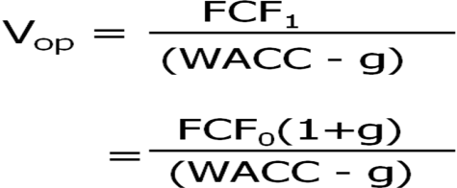

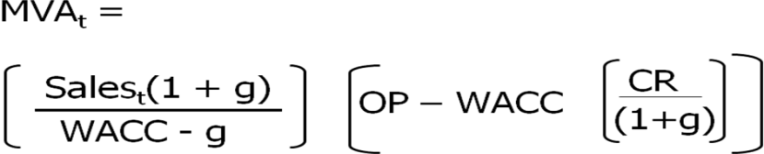



EVA = (Operating Capital) (ROIC – WACC)



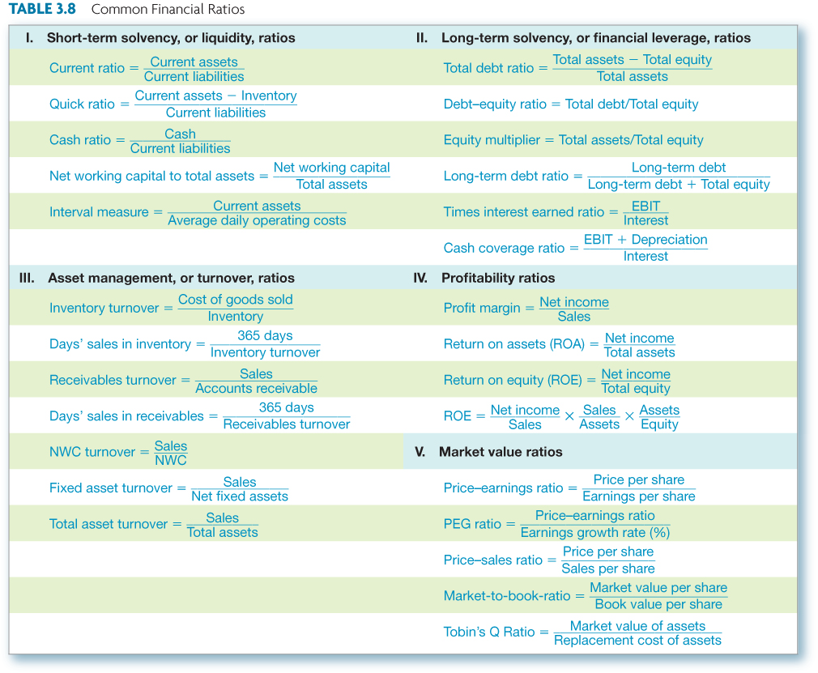

DuPont Identity= Net Profit Margin x Asset Turnover x Equity Multiplier

Equity Multiplier = 1+ D/E

Cash flow liquidity ratio = cash/ current liabilities

Cash Flow Cycle= Operating cycle – accounts payable period

Operating cycle = inventory period + accounts receivable period

Inventory period = 365 days/ inventory turnover

Receivable period= 365 days/ receivable turnover

Accounts payable period = Operating cycle –cash flow cycle.

Cash flow adequacy= (EBIT + Depreciation-Tax)/Interest PMT

Cash flow margin = (EBIT +Dep.)/sales

Cash return on assets = EBIT +Dep.)/Total Assets

* Operating cycle – time between purchasing the inventory and collecting the cash from sale of the inventory
* Inventory period – time required to purchase and sell the inventory
* Accounts receivable period – time required to collect on credit sales
* Operating cycle = inventory period + accounts receivable period
* Cash flow cycle
  + Amount of time we finance our inventory
  + Difference between when we receive cash from the sale and when we have to pay for the inventory
* Accounts payable period – time between purchase of inventory and payment for the inventory

