What is Altman’s Z-Score Model?
Altman’s Z-Score model is a numerical measurement used to predict the chances of a business going bankrupt in the next two years. It was developed by American finance professor Edward Altman in 1968 as a measure of companies' financial stability.
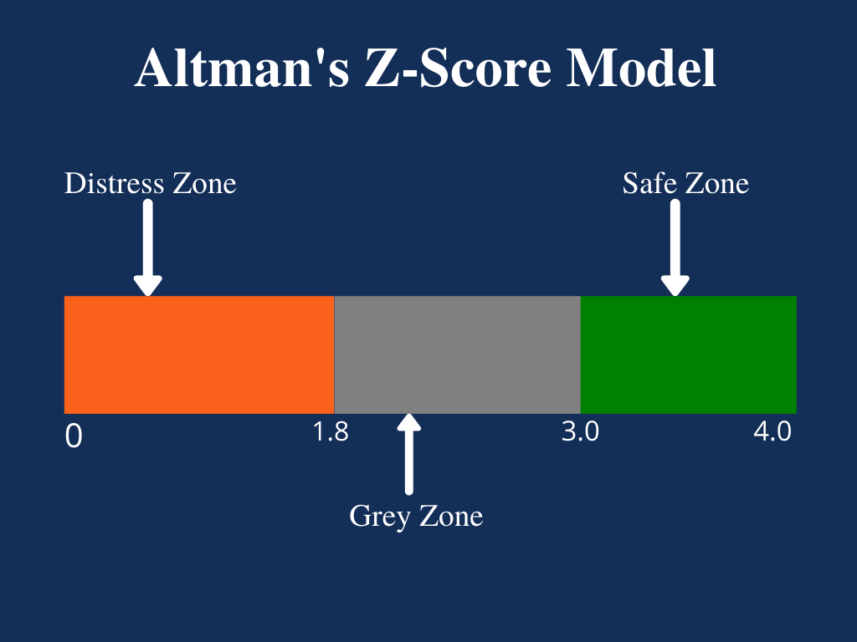

Altman’s Z-score model is considered an effective method of predicting the state of financial distress of any organization by using multiple balance sheet values and corporate income. Altman’s idea of developing a formula for predicting bankruptcy started during the Great Depression when businesses experienced a sharp rise in incidences of default.

Summary
- Altman’s Z-score Model is a numerical measurement used to predict the chances of bankruptcy.
- American Edward Altman published the Z-score Model in 1968 to measure the probability of a company going bankrupt.
- Altman’s Z-score model combines five financial ratios to predict the probability of a company becoming insolvent in the next two years.

Altman’s Z-Score Model Explained
The Z-score model was introduced to predict the probability that a company would collapse in the next two years. The model proved to be an accurate method for predicting bankruptcy several times. According to studies, the model showed an accuracy of 72% in predicting bankruptcy two years before it occurred, and it returned a false positive of 6%. The false-positive level was lower compared to the 15% to 20% false-positive returned when the model was used to predict bankruptcy one year before it occurred.
When creating the Z-score model, Altman used a weighting system alongside other ratios that predicted the company's chances to go bankrupt. In total, Altman created three different Z-scores for different types of businesses. The original model was released in 1968, and it was specifically designed for public manufacturing companies with assets of more than $1 million. The original model excluded private and non-manufacturing companies with assets less than $1 million.
Later in 1983, Altman developed two other models for use with smaller private manufacturing companies. Model A Z-score was developed specifically for private manufacturing companies, while Model B was created for non-publicly traded companies. The 1983 Z-score models comprised varied weighting, predictability scoring systems, and variables.
Altman’s Z-score Model Formula
The Z-score model is based on five key financial ratios, and it relies on the information contained in the 10-K report. It increases the model’s accuracy when measuring the financial health of a company and its probability of going bankrupt.
The Altman’s Z-score formula is written as follows:
​ζ = 1.2A + 1.4B + 3.3C + 0.6D + 1.0E
Where:
- Zeta (ζ) is the Altman’s Z-score
- A is the Working Capital/Total Assets ratio
- B is the Retained Earnings/Total Assets ratio
- C is the Earnings Before Interest and Tax/Total Assets ratio
- D is the Market Value of Equity/Total Liabilities ratio
- E is the Total Sales/Total Assets ratio

What Z-Scores Mean
Usually, the lower the Z-score, the higher the odds that a company is heading for bankruptcy. A Z-score that is lower than 1.8 means that the company is in financial distress and with a high probability of going bankrupt. On the other hand, a score of 3 and above means that the company is in a safe zone and is unlikely to file for bankruptcy. A score of between 1.8 and 3 means that the company is in a grey area and with a moderate chance of filing for bankruptcy.
Investors use the Altman’s Z-score to make a decision on whether to buy or sell a company’s stock, depending on the assessed financial strength. If a company shows a Z-score closer to 3, investors may consider purchasing the company’s stock since there is minimal risk of the business going bankrupt in the next two years.
However, if a company shows a Z-score closer to 1.8, the investors may consider selling the company’s stock to avoid losing their investments since the score implies a high probability of going bankrupt.
The Five Financial Ratios in Z-Score Explained
The following are the key financial ratios that make up the Z-score model:
1. Working Capital/Total Assets
Working capital is the difference between a company's current assets and current liabilities. The value of a company’s working capital determines its short-term financial health. Positive working capital means that a company can meet its short-term financial obligations and still make funds available to invest and grow.
In contrast, negative working capital means that a company will struggle to meet its short-term financial obligations because of inadequate current assets.
2. Retained Earnings/Total Assets
The retained earnings/total assets ratio shows a company's retained earnings or losses. If a company reports a low retained earnings/total assets ratio, it means it is financing its expenditure using borrowed funds rather than funds from its retained earnings. This increases the probability of a company going bankrupt.
On the other hand, high retained earnings to total assets ratio shows that a company uses its retained earnings to fund capital expenditures. It shows that the company has achieved profitability over the years and does not need to rely on borrowings.

3. Earnings Before Interest and Tax/Total Assets
EBIT, a measure of a company’s profitability, refers to the ability of a company to generate profits solely from its operations. The EBIT/Total Assets ratio demonstrates a company’s ability to generate enough revenues to stay profitable, fund ongoing operations, and make debt payments.
4. Market Value of Equity/Total Liabilities
The market value, also known as market capitalization, is the value of a company’s equity. It is obtained by multiplying the number of outstanding shares by the current price of stocks.
The market value of the equity/total liabilities ratio shows the degree to which a company’s market value would decline when it declares bankruptcy before the value of liabilities exceeds the value of assets in the balance sheet. A high market value of equity to total liabilities ratio can be interpreted to mean high investor confidence in the company’s financial strength.
5. Sales/Total Assets
The sales-to-total assets ratio shows how efficiently the management uses assets to generate revenues vis-à-vis the competition. A high sales-to-total assets ratio is translated to mean that the management requires a small investment to generate sales, which increases the company's overall profitability.
In contrast, a low or falling sales to total assets ratio means that the management will need to use more resources to generate enough sales, which will reduce the company’s profitability.
The Altman Z Score is used to predict the likelihood that a business will go bankrupt within the next two years. The formula is based on information found in the income statement and balance sheet of an organization; as such, it can be readily derived from commonly-available information. The Z score is based on the liquidity, profitability, solvency, sales activity, and leverage of the targeted business. Given the ease with which the required information can be found, the Z Score is a useful metric for an outsider who has access to a company's financial statements. In its original form, the Z score formula is as follows:
Z = 1.2A x 1.4B x 3.3C x 0.6D x 0.99E
The letters in the formula designate the following measures:
A = Working capital / Total assets [Measures the relative amount of liquid assets]
B = Retained earnings / Total assets [Determines cumulative profitability]
C = Earnings before interest and taxes / Total assets [measures earnings away from the effects of taxes and leverage]
D = Market value of equity / Book value of total liabilities [incorporates the effects of a decline in market value of a company's shares]
E = Sales / Total assets [measures asset turnover]
A Z score greater than 2.99 means that the entity being measured is safe from bankruptcy. A score of less than 1.81 indicates that a business is at considerable risk of going into bankruptcy, while scores in between should be considered a red flag for possible problems. The model has proven reasonably accurate in predicting the future bankruptcy of entities under analysis.
This scoring system was originally designed for manufacturing firms with assets of $1 million or more. Given the model's targeted nature, it has since been modified to apply to other types of organizations.
This approach to evaluating organizations is better than using just a single ratio, since it brings together the effects of multiple items - assets, profits, and market value. As such, it is most commonly used by creditors and lenders to determine the risk associated with extending funds to customers and borrowers.

Altman Z score for private firms:
The original formula is modified to fit in case of private firms, and the business ratios used in case of this are:
Financial ratio used | The formula for the financial ratio
A | ( Current Assets − Current Liabilities )/Total Assets
B | Retained Earnings/Total Assets
C | Earnings Before Interest and Taxes/Total Assets
D | Book Value of Equity/Total Liabilities
E | Sales/Total Assets
The actual Altman Z Score formula for this model for determining the probability for a firm to close bankruptcy is:
Z’ = (0.717 x A) + (0.847 x B) + (3.107 x C) + (0.420 x D) + (0.998 x E)
- In this model, if the Z value is greater than 2.99, then the firm is said to be in the “safe zone” and has a negligible probability of filing bankruptcy.
- If the Z value is between 2.99 and 1.23, then the firm is said to be in the “grey zone” and has a moderate chance of bankruptcy.
- And finally, if the Z value is below 1.23, then it is said to be in “distress zone” and has a very high probability of reaching the stage of bankruptcy
The original formula is slightly modified to be used in the case of firms that are non-manufacturing and operating in the emerging markets. We use only four financial ratios in this model. The four ratios are as follows:
Business ratios used | The formula for the business ratio
A | ( Current Assets − Current Liabilities ) / Total Assets
B | Retained Earnings / Total Assets
C | Earnings Before Interest and Taxes / Total Assets
D | Book Value of Equity / Total Liabilities
The actual Altman Z Score formula for this model for determining the probability for a non-manufacturing firm, operating in developed markets, to file bankruptcy is as follows:
Z’’ = (6.56 x A) + (3.26 x B) + (6.72 x C) + (1.05 x D)
The actual formula Altman Z Score formula for this model for determining the probability for a non-manufacturing firm operating in emerging markets to file bankruptcy is as follows:
Z’’ = 3.25 + (6.56 x A) + (3.26 x B) + (6.72 x C) + (1.05 x D)
- In this model, if the Z value is greater than 2.6, then the firm is said to be in the “safe zone” and has a negligible probability of filing for bankruptcy.
- If the Z value is between 2.6 and 1.1, then the firm is said to be in the “grey zone” and has a moderate chance of bankruptcy.
- If the Z value is below 1.1, then it is said to be in the “distress zone” and has a very high probability of reaching the stage of bankruptcy.
The Alman Z-Score is a widely used metric with various applications. It is one of several credit scoring models that combine quantifiable financial indicators with a limited range of variables, which help predict whether a firm will face financial failure or bankruptcy.
However, over the years since its introduction, the Z-Score has been improved to become one among the reliable predictors of bankruptcy, and many analysts nowadays use this method above any other because of its wide applications. Altman reevaluated his strategies by examining eighty-six distressed firms from 1969 to 1975 and then 110 bankrupt firms from 1976 to 1995 and later 120 bankrupt firms from 1996 to 1999. The Z-Score had an accuracy level of between 82% – 94%, which was more than that achieved by any of the methodologies that existed.
However, the “garbage in, garbage out” motto applies here as well. Therefore, if a firm’s financials, or the input data, are misleading or incorrect, the Z-Score will go wrong and will not be helpful at all in our analysis and prediction of bankruptcy.

